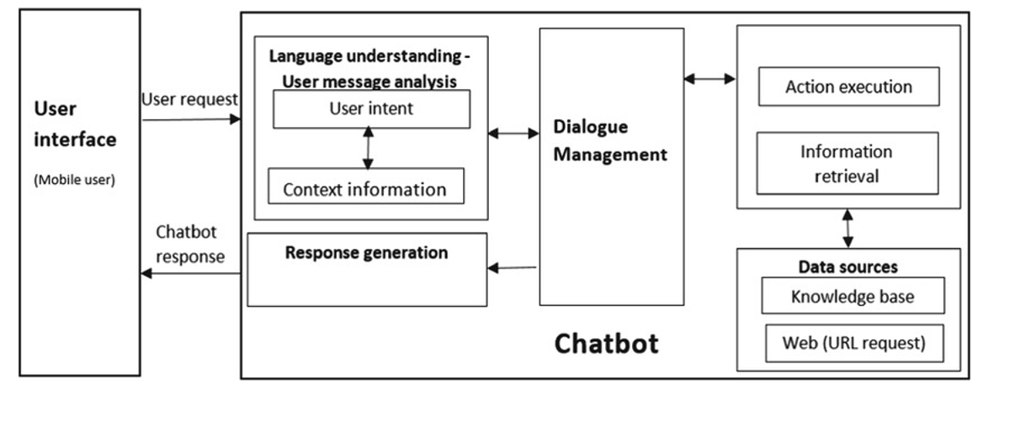Look at this architecture diagram very well. Can you help me with a well details diagram for it so i can be able to interpret it

Great — I can help you build a detailed, interpretable version of that architecture. I’ll break it down into:
- a textual, component-by-component description that you can map to any diagram tool
- a ready-to-use, labeled diagram outline (in a structured format you can paste into diagram editors like Lucidchart, draw.io, PlantUML, or Mermaid)
- a short guide on reading/using the diagram for interpretation and debugging
If you prefer, I can also generate a PlantUML or Mermaid script you can paste directly into a renderer.
- Detailed component-by-component description
- User Interface (UI)
  - Role: Entry point for mobile users; initiates user request and displays chatbot responses.
  - Interfaces:
    - Incoming: User request (text or voice converted to text)
    - Outgoing: Chatbot response, possibly with rich media
- Chatbot System (Container: “Chatbot”)
  - Subcomponents:
    - Language Understanding – User Message Analysis
      - Purpose: Extract user intent and gather contextual information
      - Internal data:
        - User intent: predicted goal or action the user wants
        - Context information: session data, conversation history, user preferences
      - Output: structured intent and context passed downstream
    - Response Generation
      - Purpose: Produce natural language (and possibly structured) responses
      - Input: current user intent, context; knowledge sources
      - Output: response text (and optional metadata)
    - Dialogue Management
      - Purpose: Orchestrate the dialogue flow
      - Responsibilities:
        - Decision on next system action (call to action execution, retrieval, clarification, etc.)
        - Manage dialogue state machine
      - Output: action requests or steering hints to downstream components
    - Data Sources
      - Knowledge Base
        - Static or dynamic facts, FAQ, policies
      - Web/URL Requests
        - Live data fetches, APIs, or web scraping for up-to-date information
      - These data sources feed the Information Retrieval and Action Execution stages
    - Action Execution
      - Purpose: Perform concrete actions required by the user, such as booking, querying databases, or triggering services
      - Interfaces: APIs, microservices, or internal modules
    - Information Retrieval
      - Purpose: Gather information needed to answer the user’s query from data sources
      - Techniques: search, retrieval, caching
  - Data flow: User request → Language Understanding → Dialogue Management → Information Retrieval / Action Execution → Response Generation → User Interface
- Data Sources (data layer)
  - Knowledge Base (KB)
    - Structured data: Q&A pairs, rules, policies, product data
    - Access patterns: read-mostly, can be cached
  - Web Request (Live Data)
    - URL-based API calls or web scrapes
    - Purpose: fetch real-time information or user-specific data
  - Data accessed by Information Retrieval and potentially by Action Execution
- Interaction Flow (high-level)
  - User submits a request via the User Interface
  - Chatbot’s Language Understanding analyzes the request to identify intent and context
  - Dialogue Management determines the dialogue path and what data is needed
  - Information Retrieval or Action Execution is invoked
    - If information is needed: fetch from Knowledge Base or Web requests
    - If an action is required: trigger appropriate services
  - Response Generation composes the chatbot reply using retrieved data and context
  - Chatbot sends the response back to the User Interface
  - Context is updated with new state for the next turn
- Diagram outline you can recreate
If you’re using a diagram tool, here is a clean, interpretable layout. I’ll describe a horizontal flow with lanes:
- Lane: User Interface
  - Box: User (Mobile user)
  - Arrow to: Chatbot System (Chatbot boundary)
- Lane: Chatbot System
  - Box: Language Understanding – User Message Analysis
    - Sub-box: User Intent
    - Sub-box: Context Information
  - Box: Dialogue Management
  - Box: Response Generation
  - Box: Data Sources
    - Sub-box: Knowledge Base
    - Sub-box: Web (URL Request)
  - Box: Action Execution
  - Box: Information Retrieval
  - Arrow flows:
    - User Request → Language Understanding
    - Language Understanding (intent/context) → Dialogue Management
    - Dialogue Management ↔ Action Execution (control signals)
    - Dialogue Management → Information Retrieval / Action Execution (data requests)
    - Information Retrieval / Action Execution → Response Generation
    - Response Generation → Chatbot → User Interface
  - Boundary: “Chatbot” encapsulating all internal components
  - Optional: Arrows showing feedback of “Chatbot response” back to UI
- PlantUML / Mermaid script (ready-to-use)
If you’d like, here are two ready-to-paste scripts.
A) PlantUML (classic UML diagram)
@startuml title Chatbot Architecture – Detailed Diagram
package "User Interface" { [User (Mobile user)] --> [Chatbot System] : User request }
package "Chatbot System" { [Language Understanding - User Message Analysis] --> [Dialogue Management] : intents, context [Dialogue Management] --> [Response Generation] : decision, turn plan [Dialogue Management] --> [Action Execution] : execute action [Dialogue Management] --> [Information Retrieval] : fetch data [Information Retrieval] --> [Response Generation] : data to answer [Action Execution] --> [Response Generation] : results to answer [Data Sources] --> [Information Retrieval] : sources [Data Sources] --> [Action Execution] : data/services [Response Generation] --> [Chatbot System] : generated reply [Chatbot System] --> [User (Mobile user)] : chatbot response }
package "Data Sources" { [Knowledge Base] [Web (URL Request)] [Knowledge Base] --> [Information Retrieval] [Web (URL Request)] --> [Information Retrieval] } @enduml
A) Mermaid (flowchart-style)
flowchart TD UI[User Interface: Mobile user] --> CM[Chatbot System] CM --> LM[Language Understanding: User Message Analysis] LM --> DM[Dialogue Management] DM --> AD[Action Execution] DM --> IR[Information Retrieval] IR --> RG[Response Generation] AD --> RG RG --> UI DM -->|controls| AD DM -->|queries| IR IR --> RG AD --> RG subgraph Data Sources KB[Knowledge Base] Web[Web (URL Request)] end KB --> IR Web --> IR
- Guidance for interpretation and next steps
- Intent vs. Context
  - Intent captures the goal: e.g., “check order status” or “update address”
  - Context includes session history, user preferences, and prior responses
  - Use the context to disambiguate intent and personalize responses
- Dialogue Management states
  - Maintain a finite-state conversation model: e.g., START → ASK_CLARIFICATION → FETCH_DATA → CONFIRM → EXECUTE → COMPLETE
  - Handle fallback gracefully (clarify when intent is unclear or data is missing)
- Data sources and latency
  - Prefer cached data from Knowledge Base for speed
  - For real-time information, invoke Web data; implement timeout and fallback
- Error handling and resilience
  - If Information Retrieval fails, the system should degrade to a safe fallback: “I’m having trouble fetching that. Can I try again or provide a rough answer?”
  - Log failures with context for debugging
- Security and privacy
  - Ensure user data handling complies with privacy policy
  - Sanitize inputs to the Knowledge Base and Web requests
  - Limit sensitive data exposure in responses
Would you like me to:
- generate a ready-to-render Mermaid diagram you can paste into a Markdown file, or
- produce a PlantUML file you can render locally, or
- tailor the diagram to a specific tool you use (e.g., draw.io, Lucidchart) with precise shapes and connectors?
If you share your preferred format, I’ll provide a version ready for your editor along with a short validation checklist.

